Day 6 Task Report

TASK : NumPy Array Manipulation Using Conditional Operations:

On Day 6, NumPy array manipulation techniques were practiced using Python. A list containing numbers from 1 to 15 was created and converted into a NumPy array. Conditional operations were then used to replace all odd numbers with 100. This task helped in understanding array manipulation and conditional filtering using NumPy functions.

- Creating a Python List:

A Python list containing numbers from 1 to 15 was created to store numerical values in sequential order.

Example:
numbers = [1,2,3,4,5,6,7,8,9,10,11,12,13,14,15]

- Converting List into NumPy Array:

The created Python list was converted into a NumPy array using the np.array() function. NumPy arrays help perform operations more efficiently than normal Python lists.

Example:
import numpy as np
arr = np.array(numbers)
print(arr)

- Replacing Odd Numbers Using Conditional Operations:

Conditional operations were used to identify odd numbers and replace them with the value 100 using NumPy array manipulation techniques.

Example:
arr[arr % 2 != 0] = 100
print(arr)

CODE:

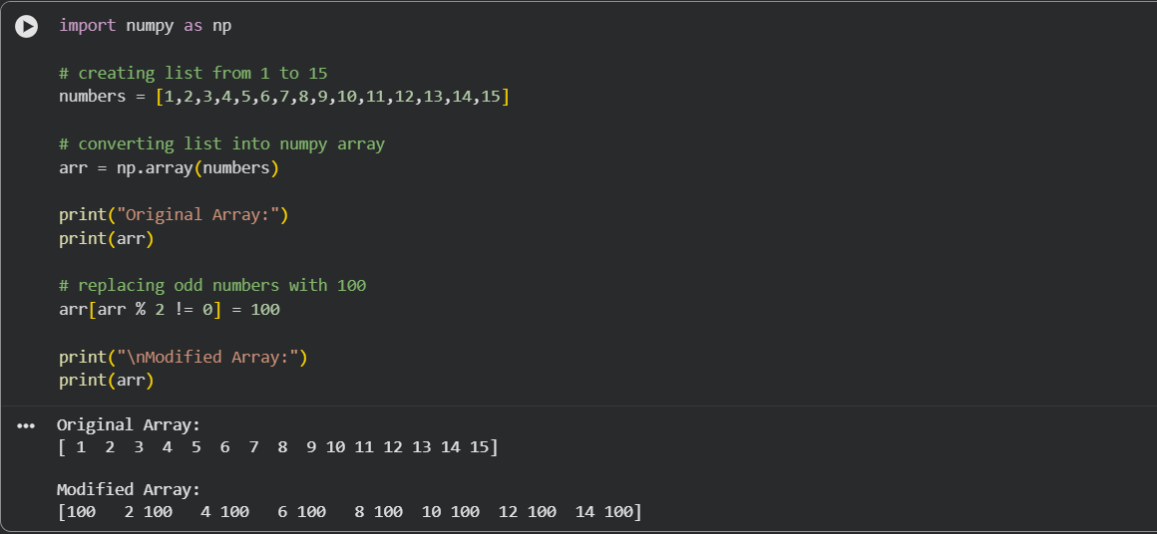

- Learning Outcome:

Through this task, I learned:
- How to create NumPy arrays
- Array manipulation techniques
- Conditional operations in NumPy
- Replacing values using conditions
- Efficient handling of numerical data

Conclusion:

On Day 6, I learned how to create a list and convert it into a NumPy array. I also practiced replacing odd numbers using conditional operations and understood basic array manipulation techniques using NumPy in Python.

